**IRE-206: Microcontroller and Interfacing IoT Lab**

**Experiment-9:** Microcontroller-based 7-Segment Display Number Sequencing.

**Theory:**

In this experiment, a microcontroller is programmed to control a 7-segment display, a common component used for numerical display applications. The 7-segment display consists of seven LEDs arranged in a specific pattern to represent numerals from 0 to 9. The microcontroller, likely an Arduino or similar platform, is programmed using the Arduino IDE or similar development environment. Each numeral (0 to 9) is represented by turning on specific combinations of LEDs corresponding to the segments needed to display the desired numeral. The experiment involves using the digital output pins of the microcontroller to selectively activate the segments of the 7-segment display according to predefined patterns for each numeral. A loop structure is implemented in the code to sequentially display the numbers from 0 to 9 with a delay between each number. The delay function is utilized to control the display timing, ensuring each numeral remains visible for a set duration before transitioning to the next numeral. This delay can be adjusted based on the desired display speed.

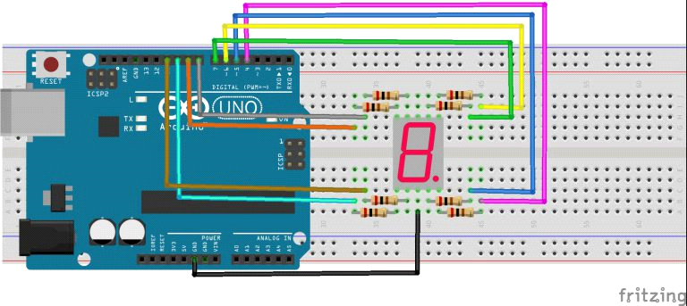

**Code:**

int a=7;

int b=6;

int c=5;

int d=11;

int e=10;

int f=8;

int g=9;

int dp=4;

//display number 1

void display1(void)

{

    digitalWrite(b,HIGH);

    digitalWrite(c,HIGH);

}

//display number2

void

  display2(void)

{

    digitalWrite(a,HIGH);

    digitalWrite(b,HIGH);

    digitalWrite(g,HIGH);

  digitalWrite(e,HIGH);

    digitalWrite(d,HIGH);

}

// display number3

void display3(void)

{

    digitalWrite(a,HIGH);

    digitalWrite(b,HIGH);

  digitalWrite(c,HIGH);

    digitalWrite(d,HIGH);

    digitalWrite(g,HIGH);

}

// display number4

void display4(void)

{

    digitalWrite(f,HIGH);

    digitalWrite(b,HIGH);

    digitalWrite(g,HIGH);

  digitalWrite(c,HIGH);

}

// display number5

void display5(void)

{

    digitalWrite(a,HIGH);

    digitalWrite(f,HIGH);

    digitalWrite(g,HIGH);

  digitalWrite(c,HIGH);

    digitalWrite(d,HIGH);

}

// display number6

void

  display6(void)

{

    digitalWrite(a,HIGH);

    digitalWrite(f,HIGH);

    digitalWrite(g,HIGH);

  digitalWrite(c,HIGH);

    digitalWrite(d,HIGH);

    digitalWrite(e,HIGH);

}

// display number7

void display7(void)

{

   digitalWrite(a,HIGH);

    digitalWrite(b,HIGH);

    digitalWrite(c,HIGH);

}

// display number8

void display8(void)

{

    digitalWrite(a,HIGH);

    digitalWrite(b,HIGH);

    digitalWrite(g,HIGH);

  digitalWrite(c,HIGH);

    digitalWrite(d,HIGH);

    digitalWrite(e,HIGH);

  digitalWrite(f,HIGH);

}

void clearDisplay(void)

{

    digitalWrite(a,LOW);

    digitalWrite(b,LOW);

    digitalWrite(g,LOW);

  digitalWrite(c,LOW);

    digitalWrite(d,LOW);

    digitalWrite(e,LOW);

  digitalWrite(f,LOW);

}

void display9(void)

{

    digitalWrite(a,HIGH);

    digitalWrite(b,HIGH);

    digitalWrite(g,HIGH);

  digitalWrite(c,HIGH);

    digitalWrite(d,HIGH);

  digitalWrite(f,HIGH);

}

void display0(void)

{

    digitalWrite(a,HIGH);

    digitalWrite(b,HIGH);

  digitalWrite(c,HIGH);

    digitalWrite(d,HIGH);

    digitalWrite(e,HIGH);

  digitalWrite(f,HIGH);

}

void setup()

{

    int i;

    for(i=4;i<=11;i++)

        pinMode(i,OUTPUT);

}

void loop()

{

    while(1)

    {   clearDisplay();

  display0();

        delay(2000);

        clearDisplay();

        display1();

        delay(2000);

        clearDisplay();

        display2();

        delay(2000);

        clearDisplay();

        display3();

        delay(2000);

        clearDisplay();

        display4();

        delay(2000);

        clearDisplay();

        display5();

        delay(2000);

        clearDisplay();

        display6();

        delay(2000);

        clearDisplay();

        display7();

        delay(2000);

        clearDisplay();

        display8();

        delay(2000);

        clearDisplay();

        display9();

        delay(2000);

    }

}

**Code for 4 digit 7 segment display:**

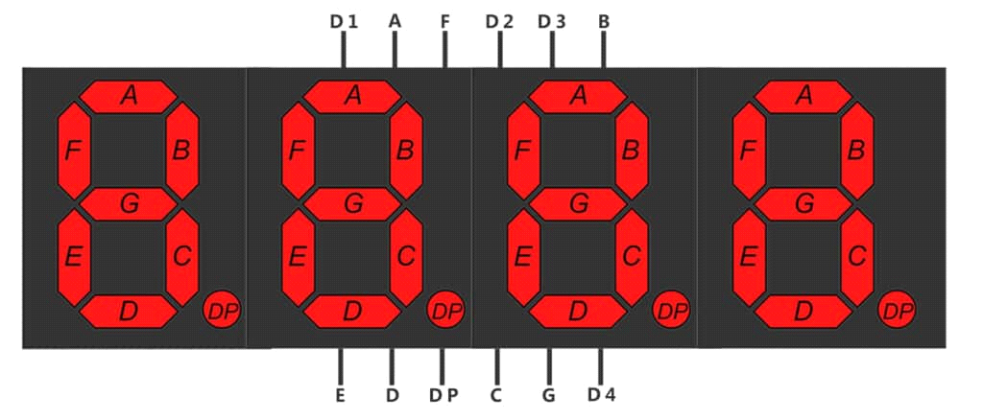

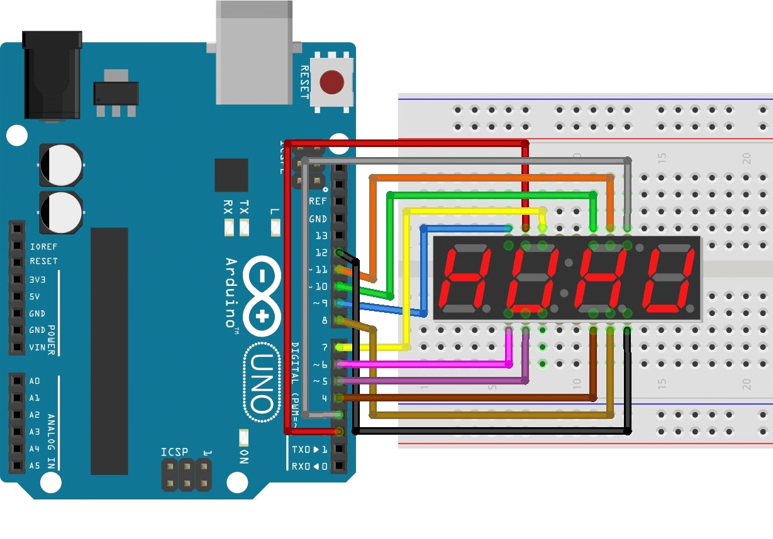

/*

Showing number 0-9 on a Common Anode 7-segment LED display

Displays the numbers 0-9 on the display, with one second in between.

A

---

F | | B

| G |

---

E | | C

| |

---

D

This example code is in the public domain.

*/

// Pin 2-8 is connected to the 7 segments of the display.

int pinA = 2;

int pinB = 3;

int pinC = 4;

int pinD = 5;

int pinE = 6;

int pinF = 7;

int pinG = 8;

int D1 = 9;

int D2 = 10;

int D3 = 11;

int D4 = 12;

// the setup routine runs once when you press reset:

void setup() {

// initialize the digital pins as outputs.

pinMode(pinA, OUTPUT);

pinMode(pinB, OUTPUT);

pinMode(pinC, OUTPUT);

pinMode(pinD, OUTPUT);

pinMode(pinE, OUTPUT);

pinMode(pinF, OUTPUT);

pinMode(pinG, OUTPUT);

pinMode(D1, OUTPUT);

pinMode(D2, OUTPUT);

pinMode(D3, OUTPUT);

pinMode(D4, OUTPUT);

}

// the loop routine runs over and over again forever:

void loop() {

digitalWrite(D1, HIGH);

digitalWrite(D2, LOW);

digitalWrite(D3, LOW);

digitalWrite(D4, LOW);

//0

digitalWrite(pinA, LOW);

digitalWrite(pinB, LOW);

digitalWrite(pinC, LOW);

digitalWrite(pinD, LOW);

digitalWrite(pinE, LOW);

digitalWrite(pinF, LOW);

digitalWrite(pinG, HIGH);

delay(1); // wait for a second

digitalWrite(D1, LOW);

digitalWrite(D2, HIGH);

digitalWrite(D3, LOW);

digitalWrite(D4, LOW);

//1

digitalWrite(pinA, HIGH);

digitalWrite(pinB, LOW);

digitalWrite(pinC, LOW);

digitalWrite(pinD, HIGH);

digitalWrite(pinE, HIGH);

digitalWrite(pinF, HIGH);

digitalWrite(pinG, HIGH);

delay(1); // wait for a second

digitalWrite(D1, LOW);

digitalWrite(D2, LOW);

digitalWrite(D3, HIGH);

digitalWrite(D4, LOW);

//2

digitalWrite(pinA, LOW);

digitalWrite(pinB, LOW);

digitalWrite(pinC, HIGH);

digitalWrite(pinD, LOW);

digitalWrite(pinE, LOW);

digitalWrite(pinF, HIGH);

digitalWrite(pinG, LOW);

delay(1); // wait for a second

digitalWrite(D1, LOW);

digitalWrite(D2, LOW);

digitalWrite(D3, LOW);

digitalWrite(D4, HIGH);

//3

digitalWrite(pinA, LOW);

digitalWrite(pinB, LOW);

digitalWrite(pinC, LOW);

digitalWrite(pinD, LOW);

digitalWrite(pinE, HIGH);

digitalWrite(pinF, HIGH);

digitalWrite(pinG, LOW);

delay(1); // wait for a second

/*

}